ELCT 302
Laboratory Report #3
Control Design and Implementation
Group #2b (Steering Group)
December 10th, 2023

I hereby certify that I have complied
with the Spirit and the Letter
of the Carolinian Creed
in preparing this report

___________________________________________
Madelyn L. Hines

___________________________________________
Jacob C. Vaught

Department of Electrical Engineering
University of South Carolina
Columbia, SC 29208

Abstract [3%]
This lab report explores the design and implementation of a Proportional-Derivative (PD) Control System for a closed-loop DC motor used in steering control. Emphasizing the use of MATLAB and Simulink for simulation and the Nyquist plot for stability analysis, the study investigates the theoretical underpinnings and practical applications of PD control. The report provides insight into the derivation of control gains, the rationale behind parameter selection, and the characterization of the system's response to various inputs. Additionally, it examines the controller's stability in both continuous and discrete time settings and assesses the potential range of steady-state error in the implemented control system. This work aims to offer a comprehensive overview of PD control systems, bridging theoretical knowledge with practical implementation in steering control.
Table of Figures
Figure 1: Definition of Percent Overshoot 6
Figure 2: Definition of Settling Time 6
Figure 3: Definition of Rise Time 7
Figure 4: Definition of Steady State Error 7
Figure 5: Description of Finite difference methods 9
Figure 6: Discrete step response 12
Figure 7: Continuous Step Response 13
Figure 8: Bode Diagram of Continuous Simulation 14
Figure 9: Nyquist Diagram 15
Figure 10: Pole-Zero Plot without Feedback 16
Figure 11: Pole-Zero Plot with Feedback 17

Table of Contents
I. Introduction [5%] 4
II. Theory [43%] 4
A. PD Control System[10%] 4
B. PD Control Design Equations[2%] 5
C. Control Design Parameters[3%] 5
D. Continuous Time Stability Analysis[10%] 6
E. Step Response Characterization[3%] 6
F. Determination of Controller Stability in Discrete Time[5%] 8
G. Derivative Approximation Method[3%] 9
H. Steady State Error[2%] 10
I. Derivative Kick[5%] 10
III. Experimental or Procedure [5%] 11
A. Simulations 11
B. Discrete Implementation 11
IV. Discussion/Results [20%] 12
A. Continuous VS. Discrete: How do the results compare? 12
B. Simulink vs Practical car: Why is there a difference? 18
V. Conclusions [5%] 19
A. Advantages and Limitations of Simulations in PID Controller Tuning 19
B. Comparative Analysis of Track Performance Versus Simulink Predictions 20
VI. Appendix 21
Simulink Model: 21
MATLAB Code: 21
VII. References 23

Exercise 3: Control Design and Implementation

Introduction [5%]
This lab report details the design and implementation of a Proportional-Derivative (PD) control system for precise and efficient steering control in an electric autonomous car. The closed-loop system centers around a DC motor, with the PD controller acting as the core element responsible for responsive and accurate navigation.
Computational tools like MATLAB and Simulink facilitated simulations, enabling visualization and analysis of the system's behavior. The Nyquist stability criterion ensured reliable operation under diverse conditions. Practical application involved integrating the control system into the car's steering mechanism and conducting thorough testing to validate performance under various inputs and disturbances. The report is structured into three sections:
- Theory: Nine detailed subsections provide a comprehensive foundation, covering PD control principles, design equations, parameter selection, stability analysis, step response characterization, discrete-time stability, derivative approximation, steady-state error, and derivative kick.
- Procedure: Focuses on designing, simulating, and implementing the steering control system.
- Discussion and Results: Presents insights and findings from MATLAB and Simulink simulations.

Theory [43%]

PD Control System[10%]
Control systems govern the behavior of dynamic systems to achieve desired outcomes. At the core of these systems is the concept of manipulating inputs to produce controlled outputs. Proportional-Derivative (PD) control systems, a subset of control systems, are particularly significant due to their ability to enhance system stability and response.
The proportional component in a PD control system is fundamental. It produces an output that is proportional to the current error value, which is the difference between the desired setpoint and the actual output. Mathematically, this is represented as:
Equation 1:
$$U_{p}\left(t\right)=K_{p}⋅e\left(t\right)$$
where $U_{p}\left(t\right)$ is the proportional control action at time $t$, $K_{p}$ is the proportional gain, and $e\left(t\right)$ is the error at time $t$. The proportional term impacts the transient response of the system, primarily affecting the system's rise time and reducing the steady-state error. However, relying solely on proportional control can lead to a steady-state error and may not be sufficient for systems requiring high precision.
The derivative component of a PD controller addresses the shortcomings of proportional control by considering the error’s rate of change. This term predicts the future trend of the error, providing a damping effect that improves system stability and response. The derivative action is given by:
Equation 2:
$$U_{d}\left(t\right)=K_{d}⋅\frac{de\left(t\right)}{dt}$$
where $U_{d}\left(t\right)$ is the derivative control action, $K_{d}$is the derivative gain, and $\frac{de\left(t\right)}{dt}$ is the rate of change of error. The inclusion of the derivative term improves the transient response by reducing overshoot and settling time, enhancing the system's ability to react to rapid changes in the error [1].
Combining these two components, the general formula for a PD controller is expressed as:
Equation 3:
$$U\left(t\right)=K_{p}⋅e\left(t\right)+K_{d}⋅\frac{de\left(t\right)}{dt}$$
This formula shows where the proportional term provides the necessary action to correct the error and the derivative term contributes by predicting future errors, thus refining the system's overall response.

PD Control Design Equations[2%]
The design of a Proportional-Derivative (PD) controller revolves around determining the appropriate control gain formulas. These formulas are crucial for ensuring the desired system performance. The derivation of these formulas involves a series of steps, including setting the forward path equality at the crossover frequency and performing algebraic manipulations to achieve the control system equality [1].
The process for the derivation of control gain formulas starts with the basic PD control Equation 3, mentioned above. The next step involves determining the transfer function of the PD controller. For a system with a PD controller, the open-loop transfer function, $G_{ol}\left(s\right)$, can be represented as:
Equation 4:
$$G_{ol}\left(s\right)=G\left(s\right)⋅\left(K_{p}+K_{d}⋅s\right)$$
where $G\left(s\right)$ is the transfer function of the plant. The goal is to adjust $K_{p}$ and $K_{d}$ so that the system meets the desired performance criteria, typically defined in terms of transient response, stability, and steady-state error.
For equality at crossover frequency, the crossover frequency, $ω_{c}$, is the frequency at which the magnitude of the open-loop transfer function equals one (or 0 dB). At this frequency, the phase margin of the system can be determined, which is critical for ensuring stability. The magnitude condition at the crossover frequency is given by:
Equation 5:
$$\left|G_{ol}\left(jω_{c}\right)\right|=1$$
To satisfy the magnitude condition, an algebraic manipulation of the PD controller's transfer function is performed. This involves setting the magnitude of $G_{ol}\left(jω_{c}\right)$ equal to one and solving for $K_{p}$ and $K_{d}$. The phase condition is also considered, where the phase of $G_{ol}\left(jω_{c}\right)$ at $ω_{c}$ should provide an adequate phase margin for stability.
The final control gain equations are derived by solving the magnitude and phase conditions. These equations determine the values of $K_{p}$ and $K_{d}$ that satisfy both the magnitude and phase criteria at the crossover frequency, thereby ensuring desired performance and stability.
The determination of the necessary magnitude and phase involves analyzing the Bode plot of the open-loop transfer function. The Bode plot provides a graphical representation of the magnitude and phase of $G_{ol}\left(s\right)$ as a function of frequency, from which $ω_{c}$ and the required phase margin can be extracted.

Control Design Parameters[3%]
The effectiveness of a PD control system hinges on its design parameters, particularly the crossover frequency and phase margin. These parameters determine the system's stability and response characteristics.
Crossover frequency (ωc), a fundamental parameter, is the frequency where the open-loop gain equals unity (0 dB). It directly affects the bandwidth, which determines response speed. While a higher ωc leads to faster responses, it can compromise stability and increase sensitivity to disturbances. Phase margin measures the system's stability margin. It's the additional phase lag needed to reach instability at ωc. A higher phase margin indicates greater stability, with reduced overshoot and improved damping. This ensures stable operation under various conditions [2].
Selecting the optimal values for these parameters requires careful balancing. Bode plots, representing the frequency response of the system, offer a visual tool to identify an appropriate ωc and its corresponding phase margin.
Remember, these parameters are interdependent. Adjusting one impacts the other. Therefore, their selection should be made in consideration of the overall system dynamics and performance objectives. Choosing the right balance between speed and stability is crucial for designing a successful PD control system.
The effectiveness of a Proportional-Derivative (PD) control system is significantly influenced by its design parameters, particularly the crossover frequency and phase margin. These parameters are critical in defining the system's stability and response characteristics.

Continuous Time Stability Analysis[10%]
Continuous time stability analysis checks if a system’s performance stays bounded over time. Two main tools for this are the Bode plot and the Nyquist stability criterion.
The Bode plot shows the frequency response of a system. It has two plots: one for the magnitude (in dB) and one for the phase (in degrees) of the system’s transfer function G(s) versus frequency. The Bode plot helps understand how the system behaves at different frequencies, especially the crossover frequencies and phase margins, which are important for stability. The magnitude plot shows how the system amplifies or reduces signals at different frequencies. The phase plot shows the phase shift caused by the system at these frequencies. Stability can be guessed from the Bode plot by looking at the phase margin at the gain crossover frequency (where the magnitude is 0 dB). A positive phase margin usually means a stable system [2].
The Nyquist stability criterion is another key tool for stability analysis, especially for systems where the Bode plot is not enough or hard to read. It uses the Nyquist diagram, which is a plot of the open-loop transfer function Gol (s) in the complex plane as s moves along the imaginary axis. The Nyquist plot helps count the number of loops around the critical point (-1+j0 in the complex plane). The Nyquist criterion says that a system is stable if the number of clockwise loops of the point (−1+j0 is the same as the number of open-loop poles in the right half of the complex s-plane) [3].
The Bode plot and the Nyquist plot work together to analyze the stability of a control system in continuous time. The Bode plot gives a better intuition of frequency response, while the Nyquist plot gives a more exact and strict way of stability analysis, especially in complex systems with delays or non-minimum phase behavior.

Step Response Characterization[3%]
Step response characterization is a fundamental analysis in control systems engineering, particularly for linear time-invariant (LTI) systems. It involves assessing the system's reaction to a step input, a signal that changes from zero to a constant value in an infinitesimally short time. This analysis is crucial for understanding the transient and steady-state behavior of a system.
The transient response refers to the part of the system's response that will eventually die out, leaving the steady-state response. Key characteristics include:
- Rise Time: The time taken for the response to go from 10% to 90% of its final value for the first time.
- Settling Time: The time required for the response to stay within a certain percentage (commonly 2% or 5%) of its final value.
- Overshoot: The amount by which the response exceeds its final steady-state value.
- Undershoot: The amount by which the response falls below its steady-state value before achieving it for the first time.
- Steady-State Error: The difference between the final output and the desired output as time approaches infinity.
The step response of a system can be represented by the equation: $Y(s)=H(s)U(s)$where $Y(s)$ is the output, $H(s)$ is the system's transfer function, and $U(s)$ is the Laplace transform of the step input. The step response can be visualized using a graph showing these characteristics [1]. The following diagram illustrates a typical step response of a second-order system:
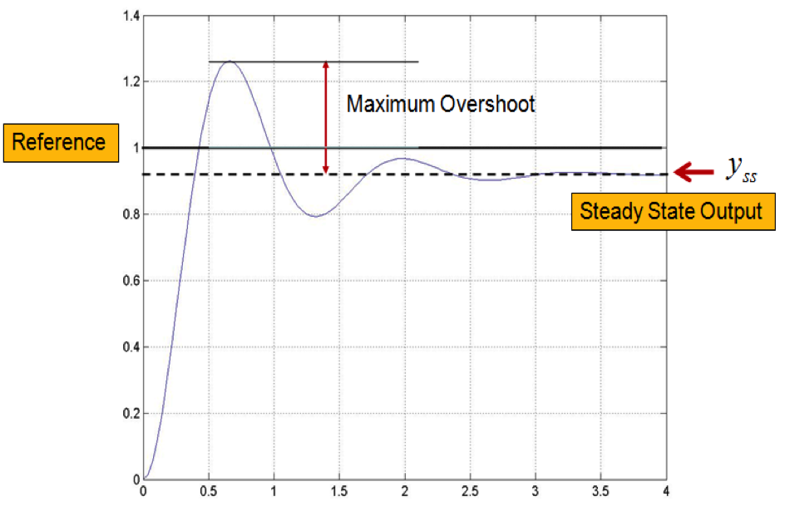
Figure 1: Definition of Percent Overshoot

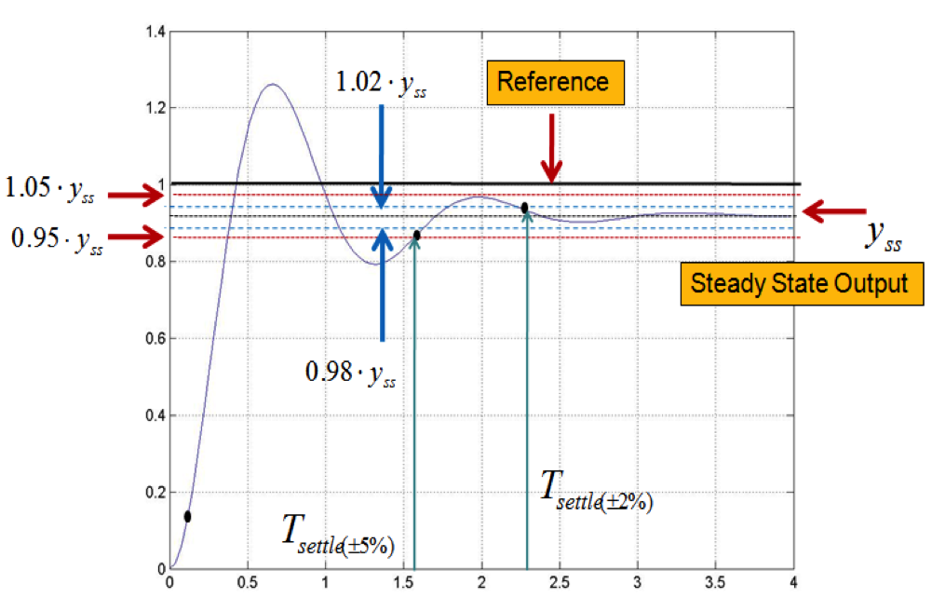
Figure 2: Definition of Settling Time

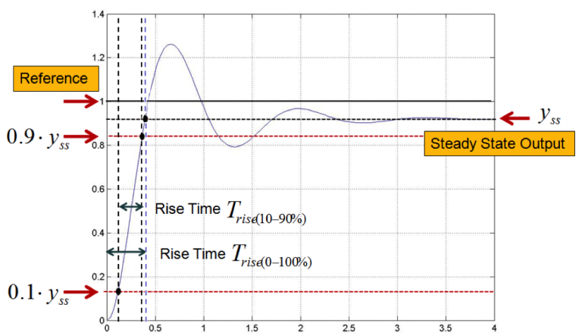
Figure 3: Definition of Rise Time
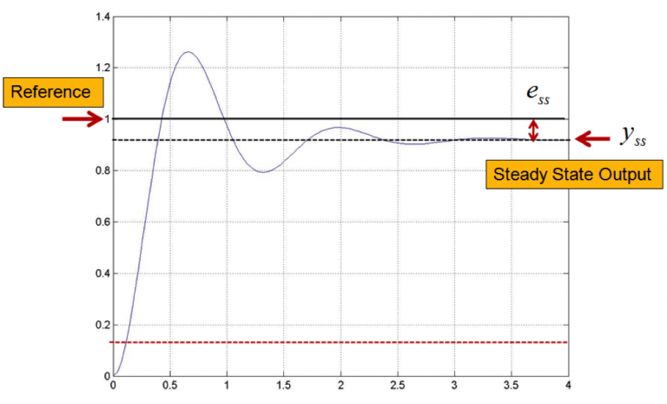
Figure 4: Definition of Steady State Error

Determination of Controller Stability in Discrete Time[5%]
Controller Stability in Discrete Time Analysis involves several key concepts and methods to ensure that a digital control system behaves predictably and remains stable under various conditions. The stability of discrete-time systems can be analyzed similarly to continuous time systems, but with some distinct differences.
- Input-Output Stability: A discrete-time Linear Time-Invariant (LTI) causal system is considered uniformly Bounded Input Bounded Output (BIBO) stable if there exists a constant L such that for any bounded input u[n], the output y[n] remains bounded within a certain limit L. This concept is crucial for ensuring that the system doesn’t produce unexpectedly large outputs in response to bounded inputs.
- Impulse Response Matrix: The impulse response matrix G[n] of a discrete-time system can be defined in terms of the system matrices A, B, and C. The system is BIBO stable if the sum of the norms of G[n] over all non-negative n is less than or equal to a positive constant L.
- Stability of Transfer Function: In Multi-Input Multi-Output (MIMO) discrete-time systems, BIBO stability is achieved if every pole of every transfer function in the transfer function matrix has a magnitude less than 1, meaning all poles must lie inside the unit circle on the Z plane.
- Lyapunov Stability: The discrete version of the Lyapunov stability theorem is applied to digital systems. A digital system is asymptotically stable if there exists a unique matrix M that satisfies the Lyapunov Equation $A^{T}MA-M=-N$ for every positive definite matrix N.
- Poles and Eigenvalues: Every pole of the transfer function G(z) is an eigenvalue of the system matrix A. For stability, all these eigenvalues must have magnitudes less than 1. If the magnitude of any eigenvalue is greater than 1, the system is unstable.
To determine the stability of a discrete-time controller and its ability to reject disturbances, one typically examines the system's response to set inputs (like step or impulse inputs) and external disturbances. This involves analyzing the closed-loop transfer functions, eigenvalues, and Lyapunov stability criteria [3].
In practical digital control systems, finite word lengths can introduce additional complexity. Issues like finite precision in real number representation and error compounding in feedback loops must be considered. These factors can affect the stability and performance of the system, especially in systems with high feedback gains.

Derivative Approximation Method[3%]
The concept of derivative approximation in relation to sample time, particularly in the context of numerical methods like finite difference methods (FDM), is a fundamental aspect of numerical analysis and digital control systems.
Finite difference methods are used to approximate derivatives by discretizing the function at a finite number of steps, typically on a grid. This involves approximating the value of the solution at discrete points by solving algebraic equations containing finite differences and values from nearby points. The basic idea is to replace the derivative in a differential equation with a difference quotient that approximates this derivative [2]​​.
The Taylor series expansion is a crucial tool in deriving approximations for derivatives. For instance, the forward difference formula for approximating the first derivative at a point $x_{j}$ is derived by evaluating the Taylor series at $x=x_{j+1}$ and solving for $f^{'}\left(x_{j}\right)$. This leads to:
$$f^{'}\left(x_{j}\right)≈\frac{f\left(x_{j+1}\right)-f\left(x_{j}\right)}{h}$$
where h is the step size, and the accuracy of this approximation is $O(h)$.
The stability of the derivative approximation is closely related to the choice of sample time or step size h. Smaller step sizes generally lead to higher data quality and simulation accuracy but increase the computational load. Conversely, larger time steps increase simulation speed but may introduce instabilities and reduce data quality. The balance between data quality and computational efficiency is crucial [1].
Different finite difference formulas offer various ways to estimate the slope or derivative at a given point. The three main types are:
- Forward Difference: Estimates the slope at $x_{j}$ using the line connecting $\left(x_{j},f\left(x_{j}\right)\right)$ and $\left(x_{j+1},f\left(x_{j+1}\right)\right)$.
- Backward Difference: Estimates the slope at $x_{j}$ using the line connecting $\left(x_{j-1},f\left(x_{j-1}\right)\right)$ and $(x_j, f(x_j))$.
- Central Difference: Estimates the slope at $x_{j}$ using the line connecting $\left(x_{j-1},f\left(x_{j-1}\right)\right)$ and $\left(x_{j+1},f\left(x_{j+1}\right)\right)$
These methods vary in their accuracy and computational complexity, and the choice depends on the specific requirements of the problem being solved.
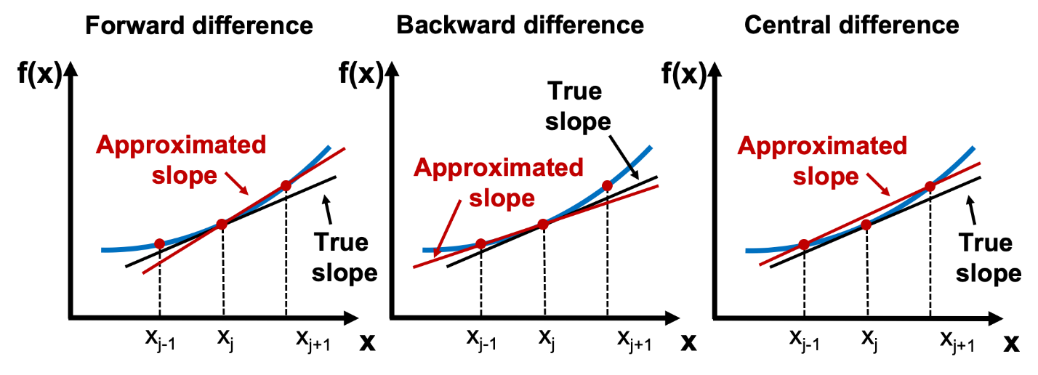
Figure 5: Description of Finite difference methods

Steady State Error[2%]
In a speed control system, the steady-state error measures the discrepancy between the desired and actual motor speeds once the system stabilizes. The lab code uses a Proportional-Integral (PI) controller to minimize this error by adjusting motor speed in response to the difference between set and actual voltage feedback. This setup is crucial for maintaining consistent motor speed despite external disruptions or operational changes. An interrupt-driven mechanism in the code continuously samples and adjusts motor speed to ensure stability and effective disturbance rejection, enhanced by anti-windup features to prevent controller saturation [3].

Derivative Kick[5%]
Derivative kick in a control system refers to the sudden change in the output of a PID controller's derivative term when there's a change in the set point. This can cause large and potentially destabilizing control actions. The code provided implements a PID controller for steering control, where the derivative term (Kd) is calculated based on the difference between the current and previous sensor readings. This implementation mitigates derivative kick by only reacting to changes in sensor values (indicating actual changes in the environment) rather than changes in the set point. Thus, the derivative action is more smooth and less prone to causing instability in the system's response [3].

Experimental or Procedure [5%]

Simulations
The MATLAB code developed is a comprehensive script designed for the simulation and analysis of a self-driving car's control system. It starts by preparing the MATLAB environment, using commands to close all open windows, clear all variables, and clear the command window. This ensures a clean slate for the execution of the code.
Following this, the script defines a series of dynamic coefficients that characterize the physical properties of the car, such as its mass, moment of inertia about the Z-axis, the lengths between the center of mass and the front and rear axles, and the cornering stiffness of the front and rear tires. Additionally, the constant velocity of the car and the distance from the center of mass to the sensor are specified. These parameters are crucial for constructing a realistic dynamic model of the car.
The core of the code lies in constructing and analyzing the transfer function of the car's dynamic model. This is done using a state-space representation, which is then converted into a transfer function. This transfer function represents how the state of the car (like its position and velocity) changes over time in response to various inputs and is central to understanding the car's behavior under different conditions.
The code also includes a section on defining the servo motor's coefficients and its transfer function. This is important because the servo motor plays a crucial role in steering the car, and understanding its dynamics is key to designing an effective control system.
The script then sets up the gains for the forward loop of the control system, which includes factors like the gear ratio and sensor sensitivity. This leads to the construction of an open-loop transfer function, which combines the dynamics of the car and the servo motor. The script generates a Bode plot for this open-loop system, which is useful for analyzing the system's frequency response.
A significant portion of the code is dedicated to designing and integrating a Proportional-Derivative (PD) controller. This involves selecting appropriate gains to ensure that the car responds correctly to deviations from its desired path. The script calculates these gains based on desired specifications like crossover frequency and phase margin. The controller is then combined with the open-loop system, and various plots (like Margin, Nyquist, and Pole-Zero plots) are generated to analyze the behavior of the system with the controller in place.
Finally, the script concludes by examining the closed-loop system, which includes the feedback loop. This part of the code evaluates the overall stability and performance of the control system using a Pole-Zero plot and a step response. This comprehensive analysis is crucial for ensuring that the self-driving car behaves predictably and safely under various conditions.
This MATLAB code is an in-depth tool for simulating and analyzing the control system of a self-driving car. It covers everything from defining the car's physical characteristics to designing a control system and evaluating its performance, both in open-loop and closed-loop configurations. This detailed approach is vital for developing a reliable and safe autonomous vehicle.

Discrete Implementation
The code is for developing a self-driving car that follows a track using a Proportional-Integral-Derivative (PID) controller, and the setup involves both hardware and software components. Initially, the <Servo.h> library is included to control the servo motor, and a Servo object named myservo is created. This object will manage the servo attached to the car for steering.
In the code, constants and variables are defined to manage the servo and sensors. The servo is connected to a designated pin (servoPin), and an LED (ledPin) is used for status indication. The PID controller constants (Kp, Ki, Kd) are crucial for determining the car's steering response and need to be tuned based on specific car and track conditions. Sensor pins are set for the left and right sensors to detect the car's position relative to the track. Variables for the PID controller, such as positionError, integral, derivative, and correction, are initialized for later use.
The setup() function in the Arduino code attaches the servo to its pin, sets the sensor and LED pins as input and output, respectively, and initiates serial communication for debugging purposes. In the main loop, loop(), the car reads values from the left and right sensors and calculates the positionError. This error measures how far the car deviates from the center of the track. The PID control algorithm then calculates the rate of change in sensor values (derivative) and applies the PID formula to determine the necessary correction to the steering. This correction adjusts the servoValue, which in turn alters the steering angle. The value is constrained to ensure it remains within the servo's operational range.
For physical setup, the servo motor is connected to its assigned pin on the microcontroller, and the left and right sensors are attached to their respective pins. The LED is connected to indicate the system's status, and all components must be correctly powered. The car's physical assembly should align with the sensor and servo setup to ensure proper functioning.
Once the code is uploaded to an Arduino or a similar microcontroller and the car is placed on the track, it's essential to observe its behavior and adjust the PID constants (Kp, Ki, Kd) accordingly. This process involves some trial and error to optimize the car's track following capability. The code leverages the PID controller to adjust the car's steering based on its deviation from the track's center, a fundamental concept in many self-driving car prototypes.

Discussion/Results [20%]

Continuous VS. Discrete: How do the results compare?
The differences between the MATLAB (continuous) and Simulink (discrete) results for a step response (Figure 6 & 7) can be attributed to several factors, including the discretization of the signal and the presence of a disturbance in the Simulink model. Here are some of the key reasons for the differences observed in the graphs:
- Discretization of Input Signal: In the continuous domain, the step response is calculated based on a continuous-time model, where the signal can change at any point in time. However, in the discrete domain (like in Simulink), the input signal is discretized, meaning it is sampled at discrete time intervals. This can introduce a delay in the response and can also cause a different rate of change compared to the continuous model.
- Sampling Time: The discrete system in Simulink is subject to a sampling time, which defines the intervals at which the system's state is updated. If the sampling time is too long, it can cause aliasing, where high-frequency components of the step response are not accurately represented.
- Disturbance: The presence of a disturbance in the Simulink model would mean that there are external factors affecting the system's response that are not present in the continuous MATLAB model. This can cause variations in the amplitude and settling time of the step response.
- ZOH (Zero-Order Hold): When discretizing the input signal, Simulink may use a zero-order hold, which holds the input constant between samples. This can cause a stair-step effect in the response, as seen in the discrete response graph.
- Algorithm Differences: The algorithms used for solving the continuous system in MATLAB and the discrete system in Simulink can differ. MATLAB may use an analytical or numerical approach that directly computes the response, whereas Simulink simulates the system's behavior over time, which can introduce computational differences.
- Numerical Precision and Calculation Errors: In any simulation, numerical precision and calculation errors can accumulate, especially over longer simulation times. These can be exacerbated in discrete simulations where the step size determines the granularity of the results.
- Initial Conditions: The initial conditions of the system can be handled differently in continuous and discrete systems, potentially leading to different transient behaviors before the system settles.

The graphs show these differences visually. The continuous response graph from MATLAB shows a smooth curve, while the Simulink response, with discretization and disturbance, exhibits a slightly different behavior, particularly at the beginning of the response (possibly due to the disturbance and discretization effects).

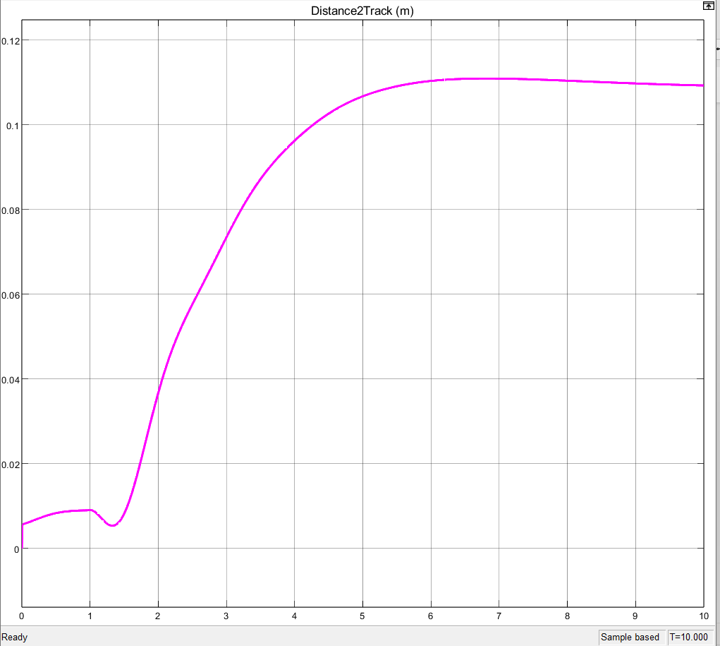
Figure 6: Discrete step response
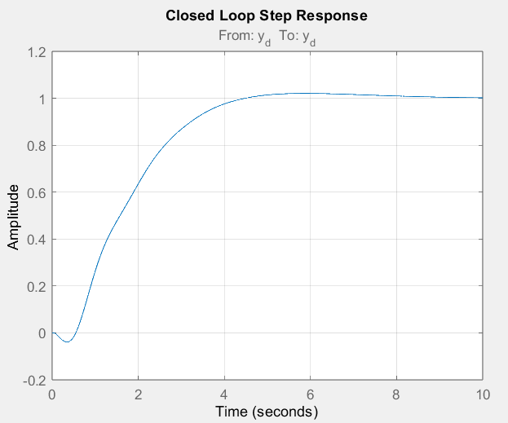
Figure 7: Continuous Step Response
The Bode plot from the MATLAB simulation is shown in Figure 8, which is a graphical representation of the frequency response of a linear, time-invariant system. A Bode plot is typically composed of two graphs:
- Magnitude Plot (Top): This plot shows the gain of the system in decibels (dB) versus the frequency in radians per second (rad/s). The gain is a measure of how much the system amplifies or attenuates an input signal at different frequencies. In this plot, we can see that at low frequencies the gain is high and relatively flat, indicating that the system passes low-frequency signals with little attenuation. As the frequency increases, the gain decreases, showing that the system attenuates higher-frequency signals. The point where the gain crosses 0 dB (the system neither amplifies nor attenuates the signal) is particularly important in determining the bandwidth of the system.
- Phase Plot (Bottom): This plot shows the phase shift introduced by the system in degrees versus the frequency in rad/s. The phase shift indicates how much the output signal is shifted in time relative to the input signal. In this case, at low frequencies, there is little to no phase shift. As the frequency increases, the phase begins to drop off, indicating that the output signal is being delayed more as the frequency of the input signal increases.
Two critical points on these plots are labeled:
- Gain Margin (Gm): This is a measure of how much gain change is required to bring the system to instability. It is expressed in dB and given at the phase crossover frequency (the frequency where the phase plot crosses -180 degrees). In your plot, the gain margin is 14.3 dB at 3.49 rad/s, which means that the gain could increase by this amount before the system becomes unstable.
- Phase Margin (Pm): This is a measure of how much additional phase shift is required to bring the system to instability. It is expressed in degrees and given at the gain crossover frequency (the frequency where the magnitude plot crosses 0 dB). In your plot, the phase margin is 68 degrees at 0.54 rad/s, indicating the system is relatively stable. A phase margin of more than 45 degrees is generally considered a sign of good stability.
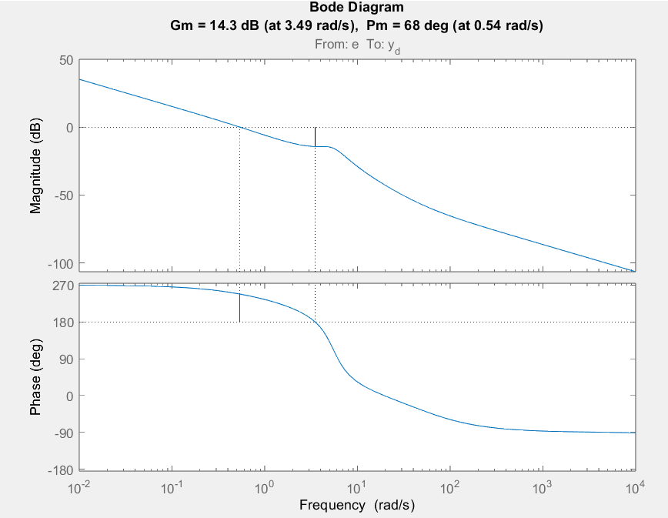
Figure 8: Bode Diagram of Continuous Simulation
The plot in Figure 9 is a Nyquist diagram, another graphical representation used in control engineering to assess the stability of a linear, time-invariant system. The Nyquist plot displays the complex-valued frequency response of a system by plotting the imaginary part of the response against the real part as the frequency varies from negative to positive infinity. It is effectively a parametric plot of the system's transfer function G(jω), where j is the imaginary unit and ω is the frequency in rad/s. In the Nyquist diagram:
- The x-axis represents the real part of the system's frequency response.
- The y-axis represents the imaginary part of the system's frequency response.
Stability is assessed by looking at how the plot encircles the point −1+0j (also called the critical point).
According to the Nyquist stability criterion, for a system to be stable, the number of clockwise encirclements of the point −1+0j by the Nyquist plot must equal the number of poles of G(s) that are in the right-half of the s-plane (unstable poles).

Key features to look for in a Nyquist plot:
- Encirclements of the Critical Point: The number of times the plot encircles the point −1+0j.
- Distance from the Critical Point: This indicates the degree of stability. A plot that passes close to the critical point suggests a low stability margin.
- Direction of Encirclements: Clockwise encirclements indicate potentially unstable poles, while counterclockwise encirclements indicate stable behavior.

In the plot, the key observations are:
- The plot does not encircle the −1+0j point. Assuming the open-loop system has no right-half plane poles, this suggests that the closed-loop system is stable.
- The distance of the closest approach to the critical point provides information about the relative stability of the system; the further away, the more stable the system is.
- The shape and size of the plot indicate how the system's gain and phase vary with frequency.
By interpreting this plot along with the system's pole-zero configuration, one can assess the stability and performance characteristics such as gain margin and phase margin.
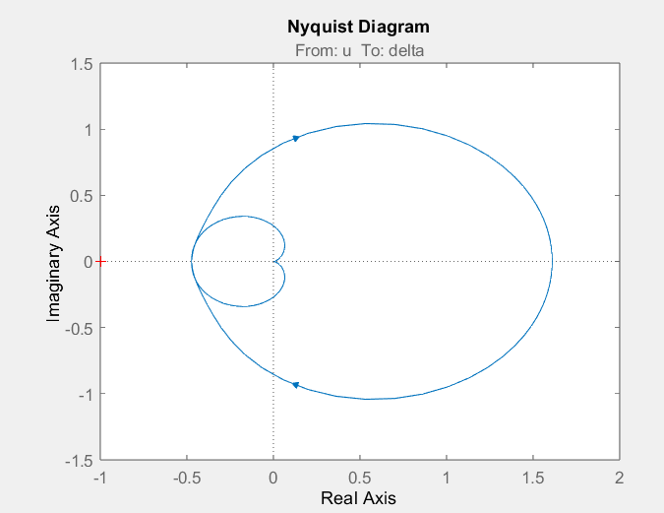
Figure 9: Nyquist Diagram
The provided plots in Figures 10 & 11 are the pole-zero maps of the control system before and after feedback is applied. Here's an analysis based on the typical characteristics of such plots:
- Forward Loop Pole Zero Plot with Controller but no Feedback:
  - The poles (indicated by 'X') represent the roots of the system's characteristic equation where the output can become infinite if the system was to be excited by certain inputs.
  - The zeros (indicated by 'O') represent the roots where the system's output becomes zero for some finite inputs.
  - For a system to be stable, all poles must be in the left-half of the complex plane. Poles on the imaginary axis (y-axis) indicate marginal stability, where the system oscillates indefinitely at those frequencies.
  - Since there are poles exactly on the imaginary axis, the system is marginally stable, meaning it neither decays nor grows over time but sustains oscillations indefinitely.
- Forward Loop Pole Zero Plot with Controller and Feedback:
  - With the feedback loop closed, the poles and zeros of the system may change locations in the complex plane.
  - The plot should be checked for any changes in the pole positions relative to the imaginary axis. Typically, feedback is used to move poles to the left, which improves stability.
  - In this case, the analysis would again depend on the exact location of the poles. If feedback has moved any previously marginally stable poles to the left of the imaginary axis, it would improve the stability of the system, leading to a stable response.

It is important to note the scale of the real axis, which is quite large (10^5). This suggests a high-speed system that responds very quickly. Such scales could also affect the interpretation of the system's behavior, particularly if the poles are close to the imaginary axis, because even a small real part can significantly affect the system's time response.

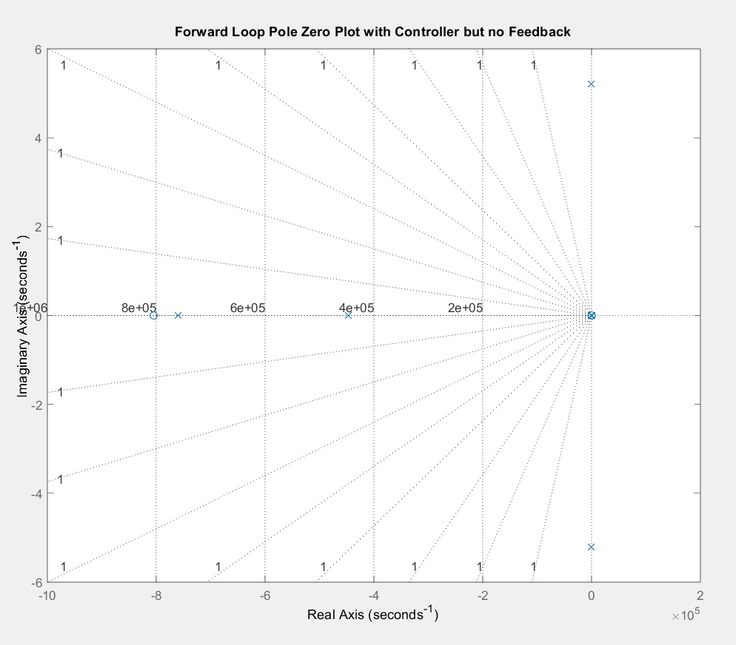
Figure 10: Pole-Zero Plot without Feedback
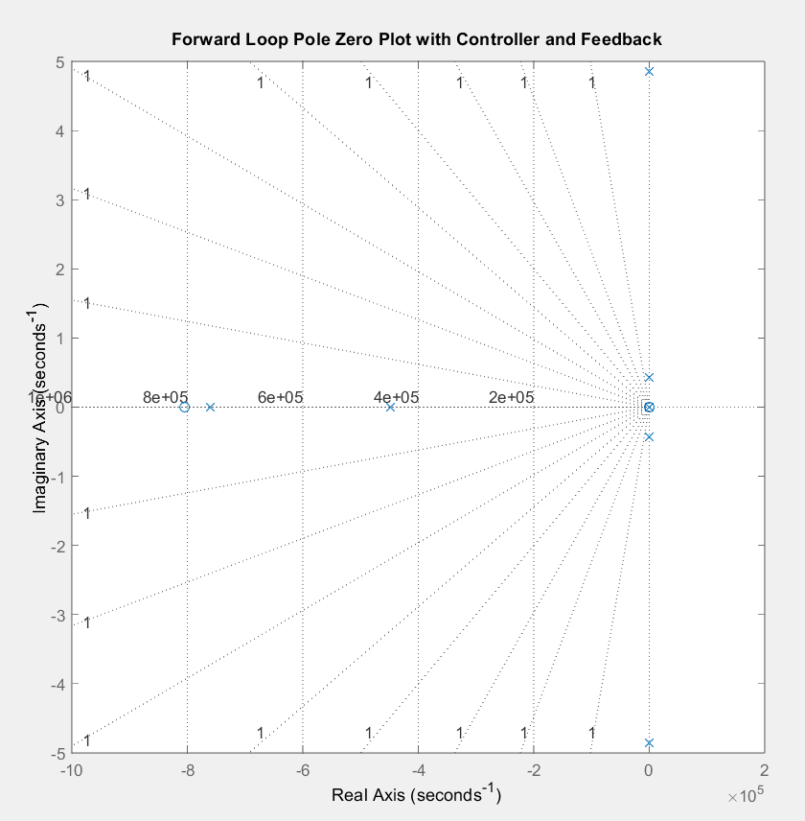
Figure 11: Pole-Zero Plot with Feedback

Simulink vs Practical car: Why is there a difference?
The discrepancy between the theoretical values obtained from the Simulink model (Kp = 1.5112, Kd = -0.0213) and the empirically tested values that yielded the best performance (Kp = 20, Kd = -5) could be due to several factors:
- Model Accuracy: The Simulink model may not perfectly capture all the dynamics of the actual system, such as nonlinearities, variable friction, tire slip, or unmodeled dynamics. If the model is an idealized or simplified version of the real system, the gains derived from simulations may not be effective in reality.
- Sampling and Discretization: If the Simulink model is discretized, the choice of sampling time could significantly impact the precision of the control signal. An improper discretization can lead to ineffective control action, reflected in the difference between simulated and actual controller parameters.
- Disturbances and Noise: The real environment where the autonomous car operates includes disturbances that may not have been accounted for in the Simulink model, such as variations in the track surface, sensor noise, or mechanical compliance in the steering system.
- Parameter Tuning and Optimization: The process of parameter tuning in the real world often involves empirical adjustments that account for many factors, including those mentioned above. It's possible that the optimization criteria used in the Simulink model did not match the criteria used when tuning the controller on the actual track.
- Sensor Dynamics and Delays: The response of the sensors and the delay in the feedback loop can greatly affect the performance of a PD controller. If these were not accurately modeled in Simulink, the simulated controller parameters would not translate effectively to the real system.
- Actuator Dynamics: Similar to sensor dynamics, the actuators (motors and servos) have their own response characteristics and delays that need to be accurately modeled for the controller parameters to be valid.
- Implementation Details: The way the controller is implemented in hardware may also introduce differences. This includes the resolution and range of the actuators, the computational delay in the microcontroller, and any other hardware-specific limitations.
- Feedback Loop: The presence and quality of the feedback signal in the actual system can significantly affect the required gains. If the feedback loop in the simulation does not accurately represent the real system, the gains will not translate correctly.
- Environmental Factors: Factors such as temperature, battery voltage, and mechanical wear can affect the performance of the PD controller but may not be present in the simulation environment.
To reconcile these differences, one could enhance the Simulink model to more accurately reflect the real system's dynamics, including disturbances and noise. Additionally, the empirical tuning process on the actual system should be informed by the simulation results, but also flexible enough to accommodate the above-mentioned real-world factors.

Conclusions [5%]

Advantages and Limitations of Simulations in PID Controller Tuning
In the execution of this project, the use of MATLAB and Simulink simulations was found to provide a controlled environment for the initial tuning of the PD Control System. Simulations afforded the opportunity to explore a wide array of conditions and control settings without the risk of damaging physical components. The cost savings associated with virtual testing were notable, given that multiple iterations could be performed rapidly without incurring the expenses of physical trials.
Simulations also enabled a visual and quantitative understanding of the control system's response to various inputs. This was particularly beneficial for educational purposes, reinforcing theoretical concepts through practical demonstration. The iterative nature of the simulations allowed for an efficient tuning process, highlighting the responsiveness of the system to changes in PD parameters.
On the other hand, the limitations of simulations became apparent when discrepancies arose between simulated and actual performance. It was observed that the model used for simulations did not fully capture the complexities of the physical system, leading to a set of PD parameters that were not optimal when applied to the actual vehicle. The phenomenon of overfitting to the simulated environment was identified, with the controlled conditions failing to represent the unpredictable variables encountered in real-world operation.
Moreover, the process of adapting simulated gains to the physical track highlighted the challenges in modeling dynamic systems accurately. Latencies and environmental factors were not replicated to a degree that would allow for a direct translation of simulation results to real-world application. The simulations, while valuable, were thus considered as a guide rather than a definitive solution for the PD tuning process.
Overall the reliance on simulations for PID tuning was shown to be beneficial for the initial stages of system design and understanding. However, it was also evident that simulations are an approximation of reality, requiring subsequent validation and refinement through empirical testing to achieve the desired system performance. The findings of this project advocate for a balanced methodology, integrating both simulations and practical experimentation to attain an optimal control system configuration.

Comparative Analysis of Track Performance Versus Simulink Predictions
Upon the transition from simulation to physical testing, the performance of the autonomous vehicle around the track was meticulously recorded and analyzed. It was observed that the empirically determined Proportional-Derivative (PD) controller parameters, which facilitated the vehicle's completion of the track in a swift 18 seconds, diverged significantly from those predicted by the Simulink model. Specifically, the Proportional gain (Kp) and Derivative gain (Kd) required adjustment to values markedly higher than those suggested by the initial simulations.
This variance highlights the critical importance of real-world testing in the validation of control systems. While the simulations provided an initial framework for understanding the system's response, they did not fully account for the complex interactions between the vehicle and the varying conditions of the physical environment. Factors such as track surface inconsistencies, actual vehicle dynamics, and real-time sensor feedback introduced variables that were not present or accurately represented in the simulation model.
The empirical results thus served to refine the simulated PD parameters, underscoring the adaptive nature of practical engineering processes. The data from real-world trials provided concrete benchmarks for performance, serving as the ultimate test for the efficacy of the control system design.
The comparative analysis between the Simulink simulations and the actual vehicle performance on the track reinforced the notion that simulations should be used as an initial step in the control system design process. Actual track testing remains indispensable for fine-tuning and validating the system to meet the intended performance criteria. The insights gained from the empirical results not only informed the final PD controller parameter settings but also offered a deeper understanding of the dynamic behavior of the autonomous vehicle in a real-world context.

Appendix

Simulink Model:
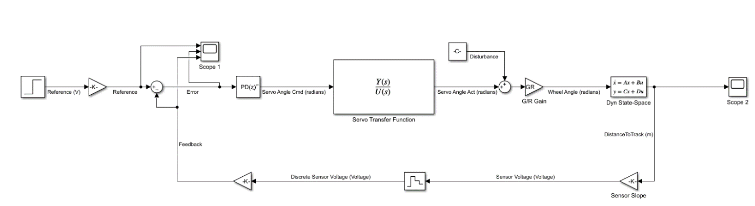

MATLAB Code:
%% Close open windows and clear command window
close all;
clear all;
clc;
%% Dynamic Coefficients
%% Dynamic Coefficients
m = 0.588;%insert value here %Kilograms mass of the car
I_z = 3.73625e-3;%insert value here %Nm Moment about the Z axis
l_f = 0.095;%insert value here %m length between the COM and the frount axel
l_r = 0.11;%insert value here %m length between the COM and the rear axel
C_alphaf = 20E3;%insert value here %N/rad Cornering Stiffness of the Front tire
C_alphar = 20E3;%insert value here %N/rad Cornering Stiffness of the Rear tire
V_x = 1/0.1;%insert value here %m/s constant speed of the car

ds = 0.1;%insert value here10cm %m distance from COM to the sensor

%% Transfer function of the Dynamic Model
A = [0, 1, 0, 0;...
0, -(2*C_alphaf+2*C_alphar)/(m*V_x), 0, -V_x-(2*l_f*C_alphaf-2*l_r*C_alphar)/(m*V_x);...
0, 0, 0, 1;...
0, -(2*l_f*C_alphaf-2*l_r*C_alphar)/(I_z*V_x), 0, - (2*((l_f)^2)*C_alphaf+2*((l_r)^2)*C_alphar)/(I_z*V_x)];;%insert value here
B = [0; (2*C_alphaf)/m; 0; (2*l_f*C_alphaf)/I_z];%insert value here
C = [0,1,ds,0];%insert value here
D = [0];%insert value here
G_dynamicsSS = ss(A,B,C,D,'StateName', {'e_1' 'e_2' 'e_3' 'e_4'},...
'InputName','delta', 'OutputName', 'y');
G_dynamics = tf(G_dynamicsSS)

%% Servo Coefficients
%Matlab Transfer Function Approximation
num = [-6.239, 9.676, 64.25]; %insert value here
denom = [1, 6.048, 40.46, 81.07, 39.91]; %insert value here

%% Transfer function of the estimated Servo Motor
G_smotor = tf(num,denom, 'InputName','u', 'OutputName', 'delta');
nyquist(G_smotor)

%% Gains of the forward loop
GR = 1; %insert value here %Gear Ratio from servo angle to turn angle
ADC = 5/1024; %insert value here %ADC conversion voltage to
SenSlope = 10; %insert value here %Ratio from distance to voltage

%% Open-loop transfer function including forward gain
G_Feedback = tf(ADC*SenSlope,'InputName','y', 'OutputName', 'y_d');
%Feedback path gain
G_plant = G_dynamics*GR*G_smotor;
G_forward = G_Feedback*G_plant; %Forward path gain

%% Bode plot of the open-loop transfer function including forward gain
figure;
bode(G_forward); %insert transfer function
title('Open Loop Bode Plot');
grid on;

%% Declaring wc and r453rwm
wc =0.54; %insert crossover frequency (rad/s)
wm = deg2rad(68); %insert phase margin

%% Frequency response
F = freqresp(G_forward, wc); %insert [transfer function, wc]
magGforward = abs(F); %magnitude for PI controller
angleGforward = angle(F); %phase for PI controller

%% Calulcating parameters for the PI controller
Kp = (1/(magGforward))*cos(pi+wm-angleGforward) %insert equation
Kd = (1/(wc*magGforward))*sin(pi+wm-angleGforward) %insert equation

%% Including the PD controller in the control loop
num1 = [Kd, Kp]; %insert Kp and Kd in transfer function form
denom1 = [1]; %insert Kp and Kd in transfer function form
G_c = tf(num1,denom1,'InputName','e', 'OutputName', 'u');
G_open = G_forward*G_c; %open-loop + controller transfer function

%% Margin plot with the PD controller but not the feedback loop
%figure;
margin(G_open);
%title('Forward Loop Bode Plot with Controller but no Feedback');
%grid on;

%% Nyquist plot with the PD controller but not the feedback loop
figure;
nyquist(G_open); %insert transfer function
title('Forward Loop Nyquist Plot with Controller but no Feedback');
grid on;

%% Pole Zero plot with the PD controller but not the feedack loop
figure;
pzplot(G_open); %insert transfer function
title('Forward Loop Pole Zero Plot with Controller but no Feedback');
grid on;

%% The complete transfer function
%Closed Loop Transfer Function from equation
Gclose = G_open/(1+(G_open)); %closed loop system transfer function
%Closed Loop Transfer Function from functions in control toolbox
% %{
sum = sumblk('e = r_d - y_d'); %Summation block from block diagram
ADC_in = tf(ADC, 1,'InputName','r', 'OutputName', 'r_d'); %referance ADC input
G_closed = connect(ADC_in, G_c, G_plant, G_Feedback, sum, 'r','y');
%connect all blocks
%}

%% Pole Zero plot of the closed loop system
figure;
pzplot(G_closed); %insert transfer function
title('Forward Loop Pole Zero Plot with Controller but no Feedback');
grid on;

%% Step response of the closed loop
figure;
step(Gclose); % plot the step response of Gclose
title('Closed Loop Step Response');
grid on;

References
- Ogata, K. (2010). Modern Control Engineering. Prentice Hall.
- Nise, N. S. (2019). Control Systems Engineering. Wiley.
- Dorf, R. C., & Bishop, R. H. (2011). Modern Control Systems. Pearson.

